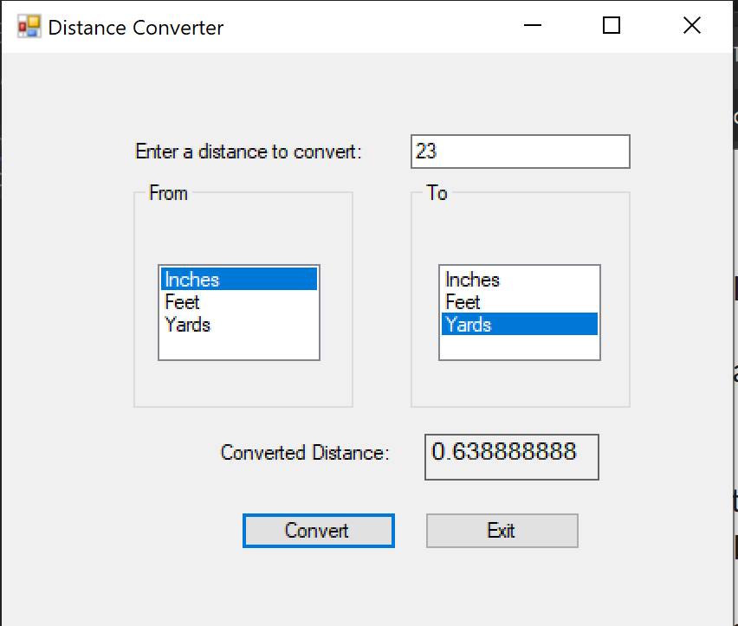

sing System;

using System.Collections.Generic;

using System.ComponentModel;

using System.Data;

using System.Drawing;

using System.Linq;

using System.Text;

using System.Threading.Tasks;

using System.Windows.Forms;

namespace Distance_Converted

{

public partial class Form1 : Form

{

//constant for convertion rates

const int FEET_INCHES = 12;

const int YARDS_INCHES = 36;

const int YARDS_FEET = 3;

public Form1()

{

InitializeComponent();

}

private void exitButton_Click(object sender, EventArgs e)

{

//close app

this.Close();

}

private void convertButton_Click(object sender, EventArgs e)

{

//on click get the entered text and convert

//if the number enter is a number

decimal enteredNumber;// = decimal.Parse(distanceTextBox.Text);

if(decimal.TryParse(distanceTextBox.Text, out enteredNumber))

{

//get the list box selections and convert to string to match

string fromConversion = fromListBox.SelectedItem.ToString();

string toConversion = toListBox.SelectedItem.ToString();

// declare converted total

decimal convertedTotal;

//if same conversion is selected display same number

if(fromConversion==toConversion) {

//if the same items on both sides are selected the total would be equal

//display the total on the label.

convertedTotal = enteredNumber;

convertedDistance.Text = convertedTotal.ToString();

}

if (fromConversion=="Inches" && toConversion=="Feet") {

//convert inches to feet by dividing by 12

convertedTotal = enteredNumber / FEET_INCHES;

convertedDistance.Text = convertedTotal.ToString();

}

if (fromConversion== "Inches" && toConversion == "Yards")

{

//convert inches to yard dividing inches by 36

convertedTotal = enteredNumber / YARDS_INCHES;

convertedDistance.Text = convertedTotal.ToString();

}

if (fromConversion == "Feet"&& toConversion == "Yards")

{

//convert feet to yard by dividing

convertedTotal = enteredNumber/ YARDS_FEET;

convertedDistance.Text = convertedTotal.ToString();

}

if (fromConversion == "Feet" && toConversion == "Inches")

{

//convert feet to inches by multiplying

convertedTotal = enteredNumber * FEET_INCHES;

convertedDistance.Text = convertedTotal.ToString();

}

if (fromConversion=="Yards" && toConversion == "Inches")

{

//convert yards to inches by multiplying

convertedTotal = enteredNumber * YARDS_INCHES;

convertedDistance.Text = convertedTotal.ToString();

}

if (fromConversion == "Yards" && toConversion== "Feet")

{

//convert yards to feet by multiplying

convertedTotal = enteredNumber * YARDS_FEET;

convertedDistance.Text = convertedTotal.ToString();

}

}

else

{

MessageBox.Show("Enter a number to convert!");

}

}

}

}